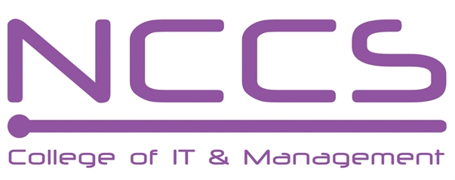
National College of Computer Studies
(NCCS-College of IT & Management)
Final Examination (2019)
BCA/First Semester/ CASO102: Society & TechnologyCandidates are required to answer the questions in their own words as far as practicable.

Full Marks: 10
Time: 20 min
Set A

[
Name:………………………………………………………………………….

NCCS Reg no :……………………………….. Section: ………………………

Attempt all the questions [10×1=10]
- Who published the subject matter of sociology to be studied in the scope of sociology, social physiology, social morphology and general sociology?
a) Horton and Hunt b) Emile Durkheim
c) Max Weber d) Talcott Parsons
- What are the major two schools of thought working in the regime of scope of sociology?
a) German and French school of thought b) British school of thought
c) Egyptian school of thought d) American school of thought
- Major rule of marriage is
a) Polygamy and polygyny b) Endogamy and exogamy
c) Monogamy and polygamy d) All of the above
- We can divide values into
a) General and specific b) Ascribed and achieved
c) Both a and b d) Non of these
- Which is not the agent of socialization
a) Family b) Peer group
c) The state d) Social stratification
- Two major paradigm in order to explain ethnicity
a) Caste and class b) Role and status
c) Sex and gender d) Mono and Poly
- The recent mode of production of technological society is based on:
a) Bow and arrow b) Agricultural tools and equipment
c) High tech machines d) above all
- Accountability of computer professionals towards society is:
a) Digital governance b) Education
c) Entertainment d) All of the above
- Major types interview are
a) Open ended b) close end
c) structured d) above all
10. Which is not the data collection technique?
a) Questionnaire b) Social survey
c) Content analysis d) SPSS

********

National College of Computer Studies
(NCCS-College of IT & Management)
Final Examination (2019)
BCA/First Semester/ CASO102: Society & TechnologyCandidates are required to answer the questions in their own words as far as practicable.

Full Marks: 20
Time:20 min
Set B

Name:………………………………………………………………………….

NCCS Reg no :……………………………….. Section: ………………………

Attempt all the questions [10×1=10]
- Auguste Comte first coined the word sociology in
- 1845 b) 1818 c) 1838 d) 1883
- Synthetic shool of thought as a scope of sociology was founded by
a) Auguste Compte b) George Simmel
c) Emile Durkheim d) Max weber
- Community is of two types in forms
a) Rural and Urban b) Hunting and Gathering
c) Non of the above d) All of the above
- Values are assumptions, largely unconscious of what is right and important said by
a) Young and Mack b) Maciver and page
c) Talcott parsons d) Robert Bierstadt
- Which is not the agent of socialization
a) Family b) Peer group
c) The state d) Primary socialization
- Caste is characterized by
a) Hierarchical division of society b) concept of pure and impure
c) Restriction on mate selection d) Above all
- Who introduce the wireless telephone in Himalayan region and established the Rastriya Abiskar Kendra?
a) Sunduk Ruit b) Mahabir Pun
c) Dayananda Bajracharya d) Luzendra Ojha
- We can divide data into two types
a) Quantitative and qualitative b) Open en and close end
c) Structured and unstructured d) All of the above
- Major criteria of validity test are
a) Test and re-test method b) Split half method
c) Multiple-form method d) above all
- Major method of research is
a) Questionnaire b) Social survey
c) Content analysis d) Inductive and Deductive

********

